**Addition Rule in Probability**

Exlusive event p (A or b) = P(A) + P(B)

Non exlusive events = p (A or b) = P(A) + P(B) – P(A Π B)

**Multiplication Rule in Probability**

Independent events:

P(A and B) = P(A) * P(B)

Dependent events:

P(A and B) = P(A) * P(B/A)

P(B/A) – B given A – Conditional probability

**Chebyshevs Inequality**

If the data does n’t follow GD we can use this equation to find probability of data

P(µ - K < x < µ + K) = 1 – 1/k2

**Covariance**

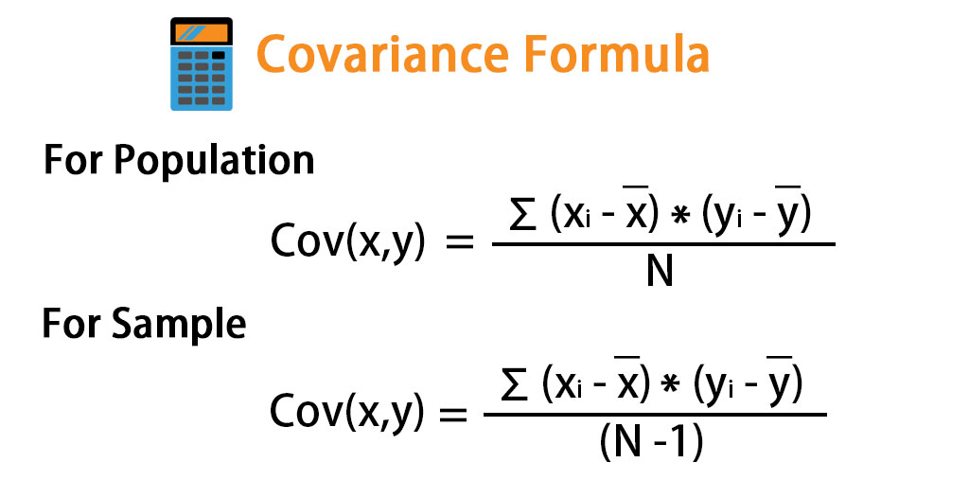

Cov(X, X) = var( X)

**Pearson Correlation Coefficient**

* Value range -1 <r <1
* Give stength and dierection of features

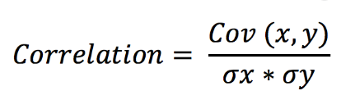

**Spearman's rank correlation coefficient**

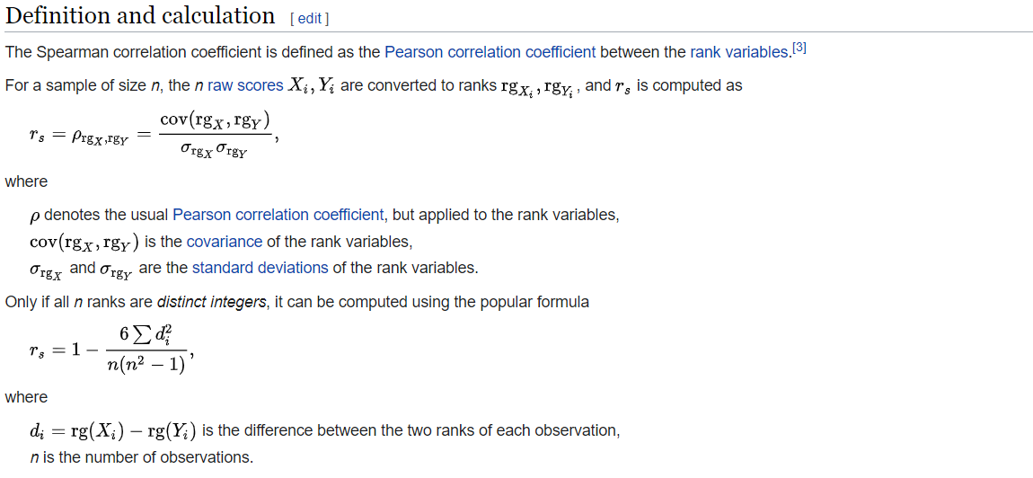

**Bernoulli Distribution And Binomial**

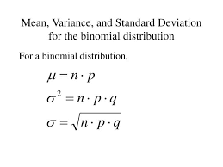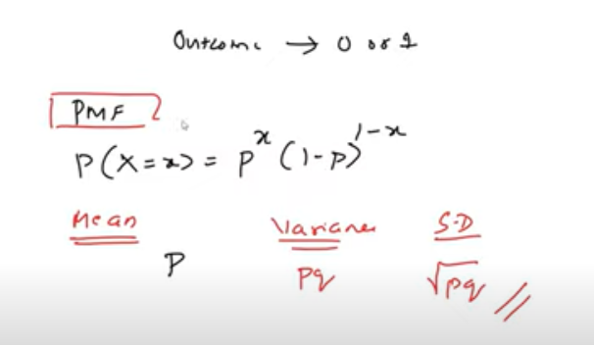

**z test**

**Z test with proportion**

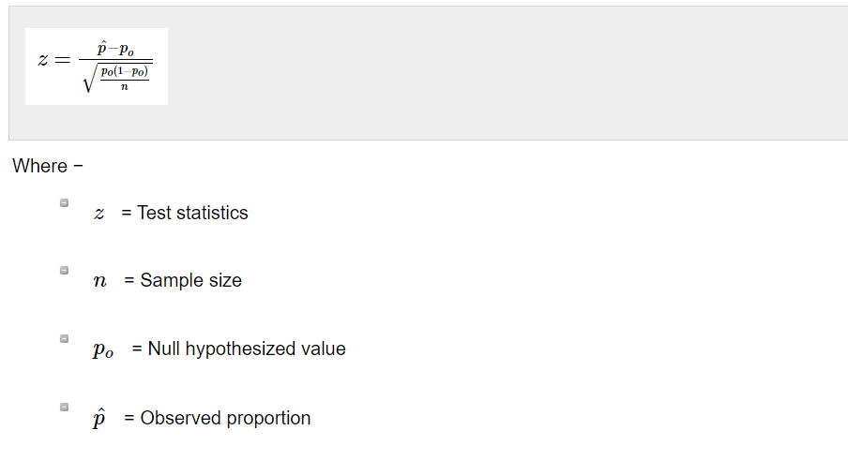

Z test when std is given

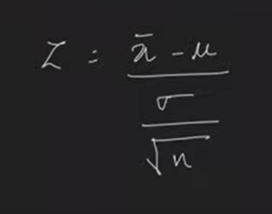

n – number of sample